Markets and the Pricing-In of War
  - Russia/Ukraine War - March 2022
Isaac Asimov — 'Violence is the last refuge of the incompetent.'

Explanation of the Conflict
Over the past few months Russia has been increasing their military presence on the border of Ukraine. A general ramping up of vocal threats led to an eventual full-scaled invasion into Ukraine, an outcome few saw as the likely reality given the human, political and economic costs of outright conflict. This invasion into Ukraine is predicated on Russia’s unwillingness to let Ukraine become a member of NATO (North Atlantic Treaty Organisation) and the strategic advantages this would create against Russia. Remember, NATO was the enemy of the Soviet Union during the Cold War. If NATO were to accept Ukraine into the alliance, NATO forces would be allowed to militarise along their border. NATO’s expansion over the years is captured by the below map. This has gradually increased the threat Russia has felt from The West and reflects their long memory of the Second World War and the cost exacted on the country (a much bigger part of the Russian national memory than we see here in Australia).
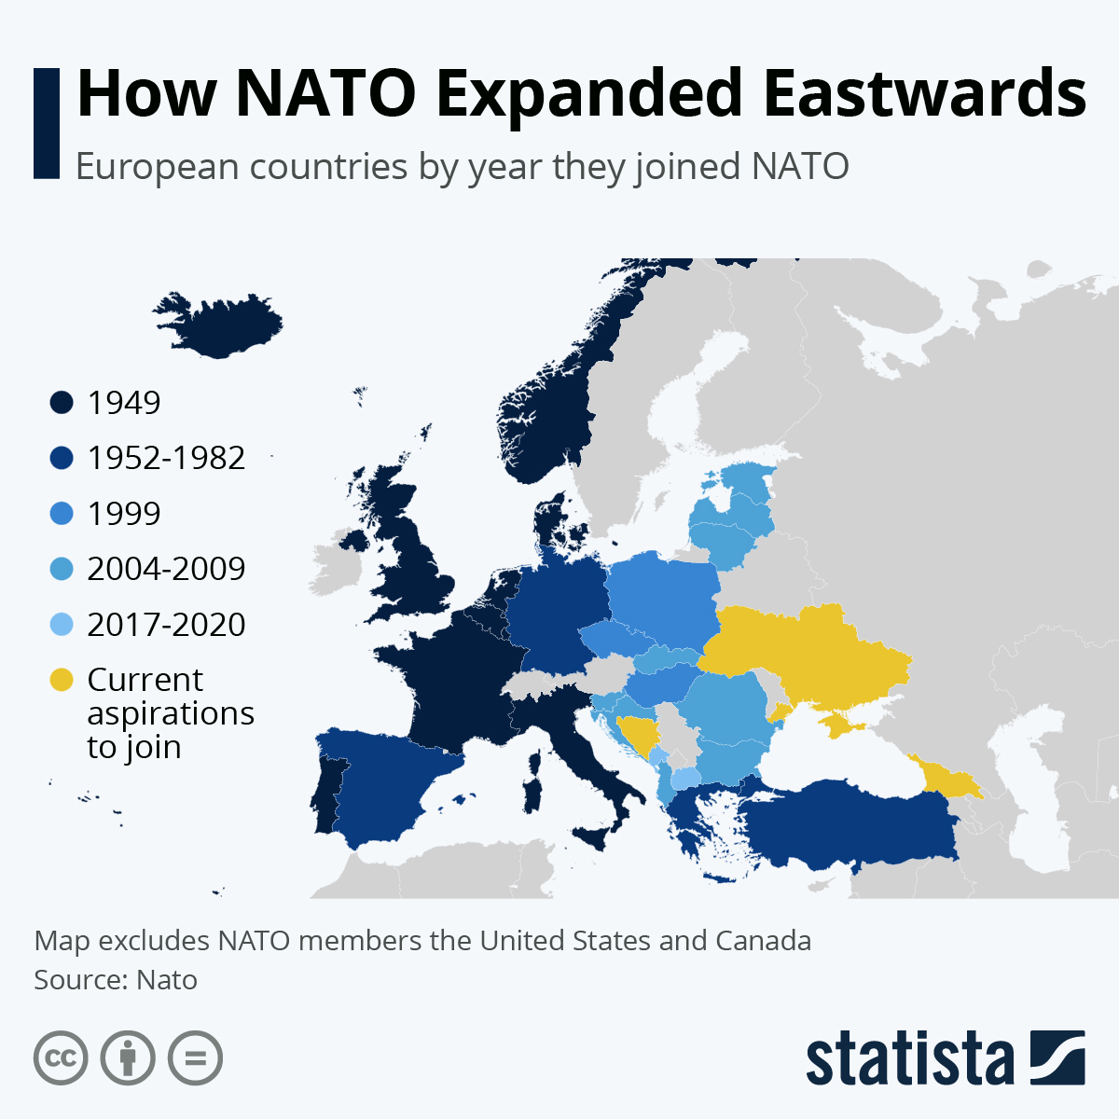
Russia has now reached the tipping point and have put the fate of Ukraine into their own hands. The decision to invade is further centred around the historical significance of this region and Russia’s own interests in maintaining regional separation from foreign military intervention and bases. This in no way gives any nation the justification to impede on one’s sovereignty. Self determination is the one sacred rule that is being broken, and the people of Ukraine are suffering due to the Russian aggression.
Since the initial invasion, the success of the Russian advance has not been inline with prior expectations. This is leading what seems to be a more frustrated Putin to use more deadly weapons with an increasingly indiscriminate nature in major cities of Ukraine.

Source: https://www.statista.com/chart/26674/european-countries-by-year-of-joining-nato/

Markets turn Volatile
Markets had a volatile start to the year as rising inflation and expectations of higher interest rates had put a lot of pressure on asset prices. Now, investors are trying to work out how to price in a war-like situation occurring in Ukraine. This is understandably causing panic. Markets fell significantly on the initial news on the invasion and safe haven assets like gold rose sharply.
Since then, there has been higher volatility in commodities and equity markets as there is no clear understanding of what this war’s actual impacts on the global economy will be. The level of unpredictability and risk remain high. The facts are that this is an isolated war in a country that has had war present between Russian Separatists and the Ukrainian Army since 2014 (notwithstanding the involvement of Russian client state Belarus). It appears unlikely that a World War III scenario is playing out and countries not directly involved in the conflict are not sending troops but rather turning this into an economic war. As an example, French Minister of the Economy, Finance, and the Recovery Bruno Le Maire declared an “all-out economic and financial war” against Russia.
Western nations have actively moved to sanction Russian banks and individuals connected to the political party. The most significant recent reaction to the Russian invasion is the agreement of the European Union, UK, US and other allied nations to remove some Russian banks from the Swift payment system. This is likely to have significant impacts on the Russian economy. In 2012, Iran was banned from this payment system. They proceeded to lose half of their oil export revenues and 30% of foreign trade. It is expected that a similar financial impact will happen to Russia as their banks become unable to send money overseas with ease. Fund manager darling Sberbank is another example seeing its shares decline over 55% year-to-date as it is forced to shutter its European operations.
The Western powers have not initiated sanctions on oil and gas at this point in time due to the heavy reliance of Europe on Russian supply. Western nations are also currently tackling inflation numbers that haven’t been around since the 1980’s (in the United States), so naturally sanctions against energy are looking to be avoided to not further exacerbate this issue. However, we note that steep discounts are being demanded of Russian oil on fear of further escalation which may also push energy prices higher.
Unfortunately, there is a high probability the energy and other commodities will get impacted by this conflict as production is disrupted during a war. As an example, Ukraine and Russia also account for one third of global wheat production which has since gone mostly offline in the Ukraine or unable to get to port. Wheat and energy prices have since moved much higher as a result.

Conclusions
This does not appear to be heading into a world war environment. The West appears to be willing to let Ukraine fight their own battle whilst aiding them with military equipment and financial sanctions on Russia. The outcome of all of this is currently unknown in its entirety as the situation evolves constantly. Shocks to commodity markets may further elevate the already rising prices and keep inflation elevated for a longer period of time. These flow on effects from war may cause further downside in markets. If there are any talks between the two nations that consist of concessions and aspects of de-escalation or a sign of the war ending, markets would likely stabilise. This is yet to be seen as the Russian war effort increases in intensity.
The Russian economy (144 million people) has a GDP roughly the same size as Australia (26 million people). Sanctions and the removal of Russian banks from the SWIFT payment system will further deteriorate the economic situation internally. The longer this war goes on, the more the people of Russia will suffer as a product of the sanctions and the more unrest is likely to occur domestically. The internal pressure to relieve the Russian economy from economic hardship may build over the coming weeks and months. The Russian Ruble has already fallen roughly 30% relative to the USD since the initial invasion bringing the value of 1 Ruble to less than one US cent.

